You’re invited to Hawthorn’s Scholastic Book Fair on November 26, 28, & 29

It’s an opportunity for families to purchase the latest and greatest in affordable children’s books while also helping build school and classroom libraries -- as a portion of sales directly benefits our school.

You’ll find hundreds of quality books for all reading levels at our Book Fair. Attached is a flyer that gives a preview of only a few of the many books available for purchase.

Your support of this event is key in helping us obtain new resources for our classrooms and library. Please note these dates and times and plan to visit our Book Fair in the Hawthorn Library:
- Tuesday, Thursday and Friday, November 26, 28, & 29
- 8:30 am to 12:00 pm, 12:30 - 3:30 pm
- **Thursday November 28 also open 6:00 to 8:00 pm**

Thank you in advance for helping to make our students lifelong readers. We look forward to seeing you and your family at our Book Fair!

Deborah Copeman, Library Support Specialist | dcopeman@hrce.ca

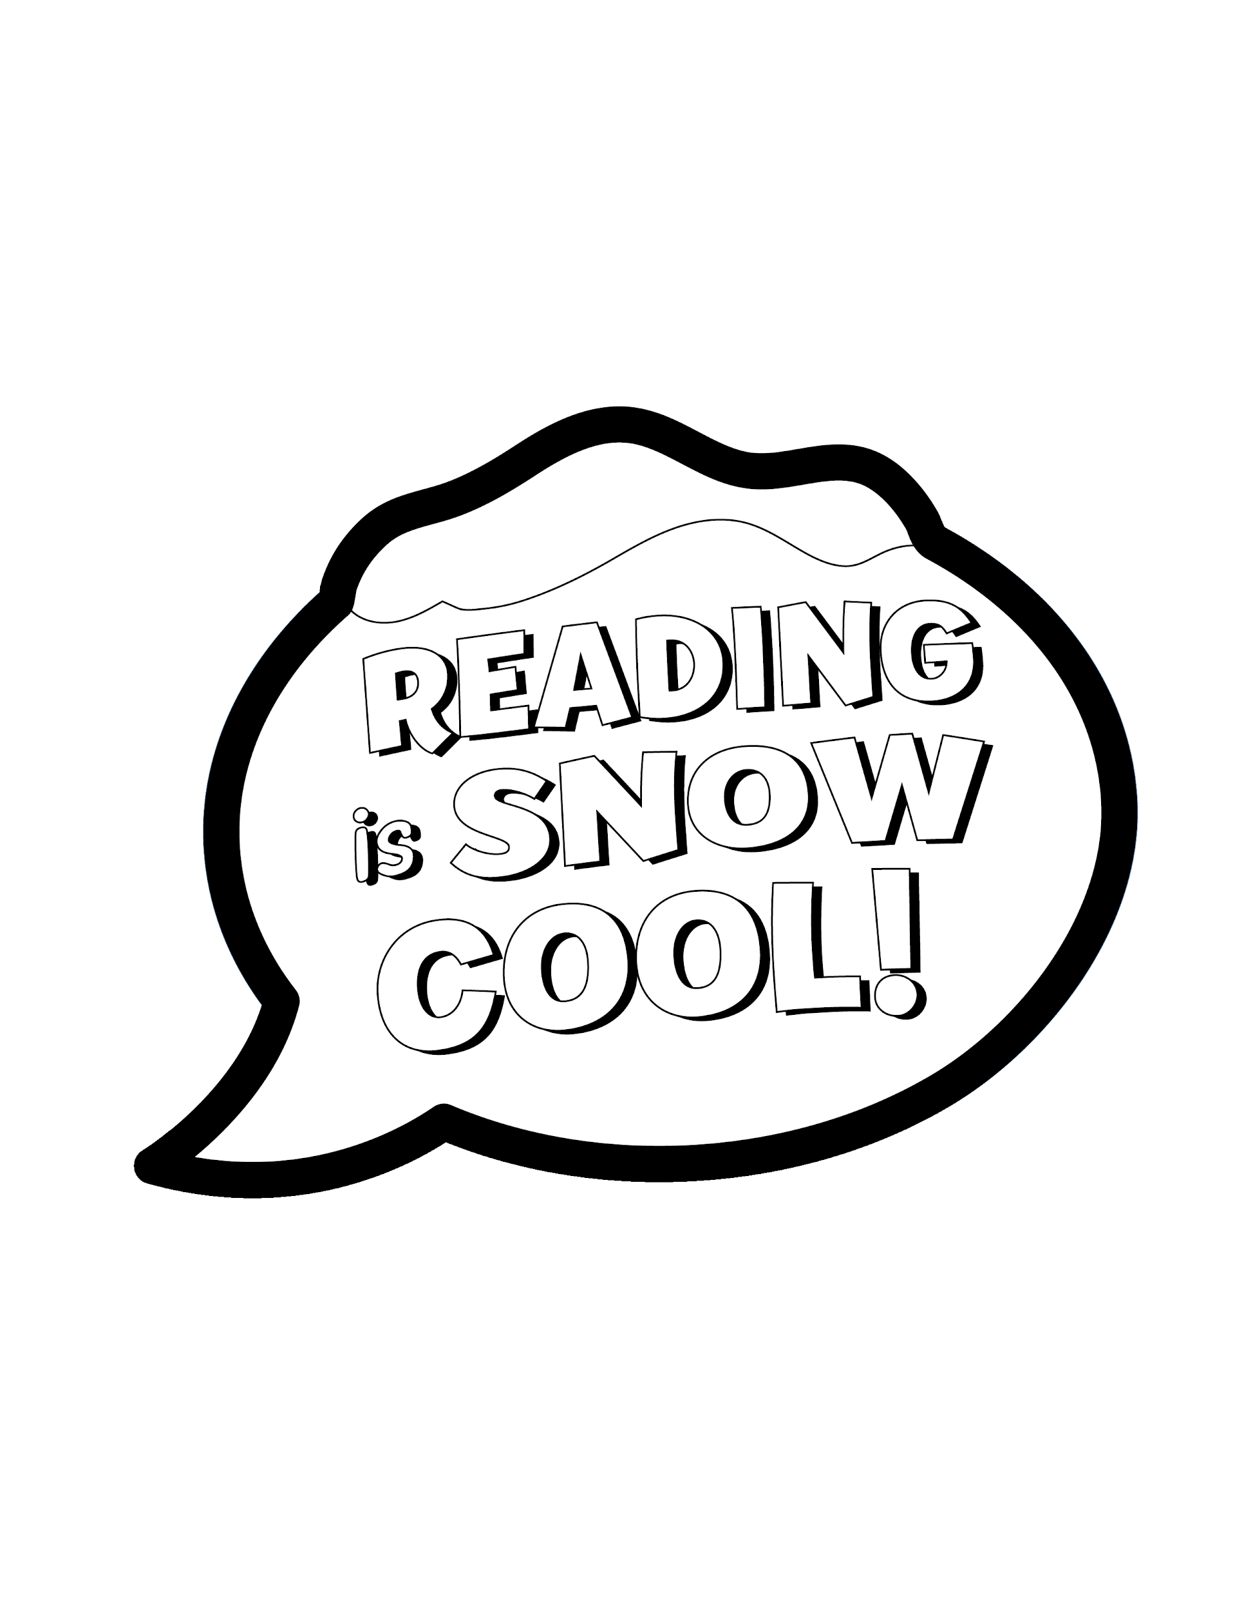

We accept cheques made payable to our school, cash, and Visa, American Express and MasterCard.

